An Investigation of the Hardness and Fatigue Behaviours of a High Temperature Cu-Based Shape Memory Alloy with Graphene Additions
Wasiu, Issa, Kwara State University, Malete, Nigeria, wasiu.issa@kwasu.edu.ng

Abstract
CuAlNi shape memory alloys (SMA) find usefulness in high temperature engineering applications. They have ease of production and are cheap in comparison with Nickel - Titanium alloys. The alloy is usually under cyclic load/stress but lacks excellent fatigue properties. In this study, the effects of graphene (C), i.e. a polymorph of carbon, on the fatigue life and hardness of CuNiAl SMA were investigated. The resulting S-N curves revealed that as the number of stress cycles increases, the magnitude of stress leading to fatigue failure reduces. Design Expert Software version 13.0 was deployed to predict the interaction between fatigue life, percentage compositions of Cu and graphene (C). The parameters were significant model terms at p < 0.05, indicating that they have significant effects on the fatigue life of SMA. The model obtained indicates a good fit with R² of 94.87%. The developed model can be employed in fatigue life study of shape memory alloys containing a fourth addition such as graphene.

Keywords: mechanical properties, shape memory alloy, fatigue life CuAlNi and CuAlNiC.
1. Introduction
Shape Memory Alloys abbreviated as SMA, have intelligent phenomenon, i.e. ability to ‘recall’ and return to their original geometry after undergoing deformation [1]. They pass through a reversible solid phase transformation [2-7]. Some examples of shaped memory alloys are Ni–Ti, Cu–Zn–Al and Cu–Al–Ni alloys [1].
A SMA undergoes a transformation between two phases; a reduced temperature called martensite and an elevated temperature called austenite [8, 9].
Recently, researches with Cu-based shape memory alloys has increased [10], due to their many interesting properties [11], such as stability at high temperatures over 100⁰C [12], ease of production and low cost [13-15], electrical and thermal conductivities properties [16], including their many applications in engineering and other fields [17].
CuAlNi SMA being an alternative to the commercial and highly expensive NiTi based SMA alloy [18] is fragile [19], brittle [20], and are not suitable for much cyclic activities [20]. In the light of these shortcomings, their commercial use is being reduced [21-23].
It can be traced from the literature that the CuAlNi SMA can be improved through grain refinement [24] with the addition of other elements [18, 25]. Karaduman and Canbay [18] added 5nm graphene nanoplatelets to CuAlNi SMA and observed that the alloy properties can be controlled. Saud et al. [26] added traced quantity of carbon nanotubes (CNTs) to CuAlNi SMA and they observed an improvement in the alloy properties. From many literatures reviewed, no report on the influence of graphene addition on the stress-number of cycles curve (fatigue life) of CuAlNi SMA and this is very important since the alloy is usually under cyclic load [27].
Fatigue failure is a phenomenon characterized with a decreasing resistance of materials to fluctuating stresses [28, 29]. Fatigue test is the process that a machined component (sample) is fractured to failure by applying known reversal stresses [29]. The stresses may be the similar or dissimilar in magnitude in both directions. The fatigue test helps us to know the amount of stress the material or component can withstand before service failure [1].
To ease problems with large experimentations and reduce cost, artificial intelligence (AI) based models can help to predict relationships among parameters. For this purpose, computer software programmes can help to predict and simulate the fatigue life of the Cu-Al-Ni shape memory alloys. These AI based referred to as phenomenological models have the potential to give a deeper and much more reliable insight into the details of fatigue behaviour of materials as they are based upon the correct relationship/equation thereby allowing for optimum design of the materials.
2.0 ExperimentaL Set-up and Methodology
Commercial quantities of 2.5kg, 1.2kg and 0.6kg of copper (Cu), Aluminium (Al), Ni (Ni) respectively, of high purity were sourced from Nigeria. Graphene nanoplatelet (C) of size 5nm, diameter 30μm, and specific surface area 170 m²/g with high purity was sourced from Nanografi Nanotechnology Company, Turkey.
The alloy was prepared through casting method. Nickel was first charged into the furnace due to its high melting point. Copper was added when the temperature of the furnace reached 1400⁰C thereafter aluminium was added. The ingot was steered to achieve a homogeneous alloy. Argon gas was used to shield the atmospheric air so as to prevent oxidation. The ingot was air cooled. It was then divided into four samples A, B. C and D. Sample A (84.3Cu-11.9Al-3.8Ni wt.%,) is the control sample. Samples B, C and D were added 0.15%, 0.3% and 0.45% graphene respectively after heating the alloy in the furnace to 1400⁰C. Finally, samples B (84.78Cu-11.25Al-3.8Ni-0.15C wt.%,), C (84.05Cu-11.32Al-3.79Ni-0.3C wt.%) and D (83.92Cu-11.85Al-3.78Ni-0.45 wt.%) were produced.
The surface morphology and samples elemental compositions were studied using Scanning Electron Microscope, Energy Dispersive X-ray Spectroscope (SEM-EDS), see Figure 2. The peaks of the X-Ray diffraction of atoms of the alloy in crystalline phase was identified using (Figure 3).
The fatigue test was carried out using the Avery Dennison 7305 Fatigue Testing Machine standards (Figure 1).
(a)
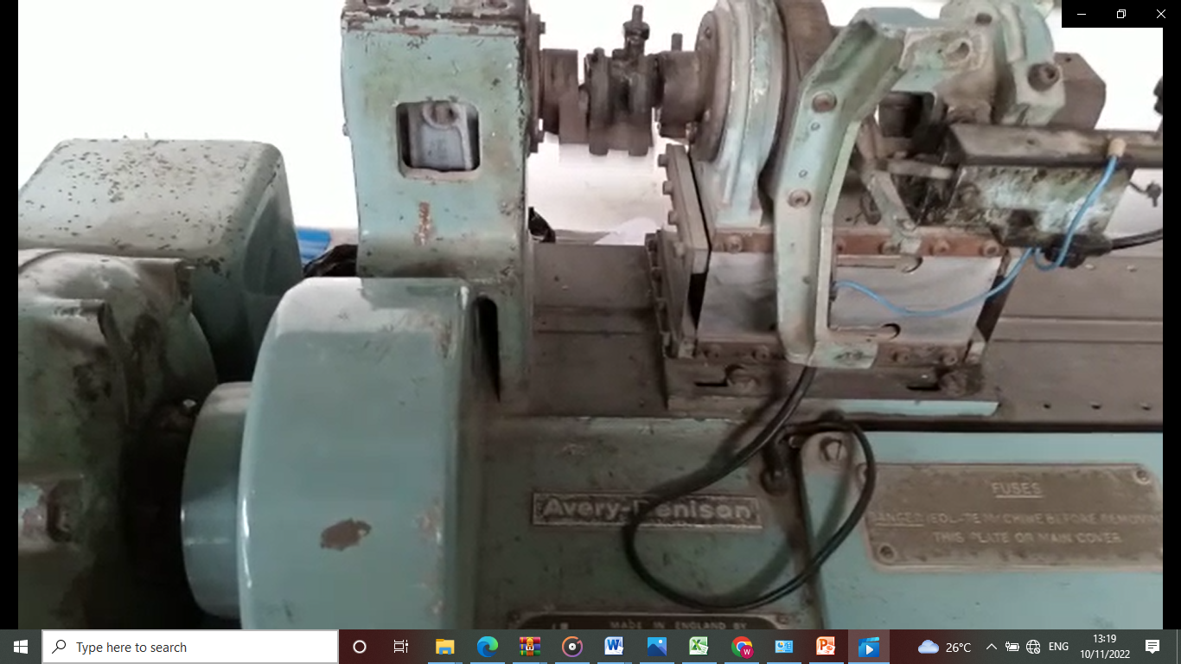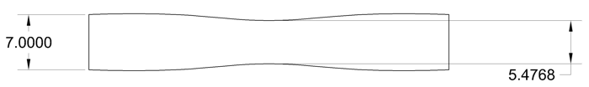
Figure 1, (a) Avery Denison Fatigue Testing Machine, (b) specimen specifications
Each of samples A, B, C and D was further produced into four specimen standards of the machine specifications. The load applied in form of bending moment was measured. The bending moment was imposed by an oscillating spindle at one end of the specimen with the aid of a connecting rod, eccentrics and crank. The revolution counter gives the values of cycles to failure (Table 1). The machine stops at specimen fracture.
The bending stress is calculated from the bending moment (30).
Stress = $\frac{Mmax}{W }$ ; (1)
Where: Mmax = Bending Moment reading from machine (Kgfcm)
W = Section Modulus = $\frac{πD^{3}}{32}$ Where: D = Diameter, G = Gauge Length
The bending moment was applied through the stair case method (30). Here, the applied bending moment was imposed and was increased with a fixed increment. This serves as the test value (bending moment) for the next specimen. The result obtained from the experiment is as shown in table 1.
Lastly, the import design under custom design methodology of Design Expert Software version 13.0 was utilized for the model formulation and statistical analysis. The values of stress and percentages of Cu, Al, Ni and Graphene (C) were five experimental parameters selected as input parameters (Table 2), while the output is the fatigue life (number of cycles). Sixteen experimental runs were utilized based on the experiment.
3.0 Results and Discussion
3.1 Surface Structure/Morphology of Samples
When the micrographs of Samples A, B, C, and D in Figure 3 are compared, it becomes clear that Samples B, C, and D have black particles in them. These particles may be connected to compound precipitations, which lead to the development of new compounds with black colours.

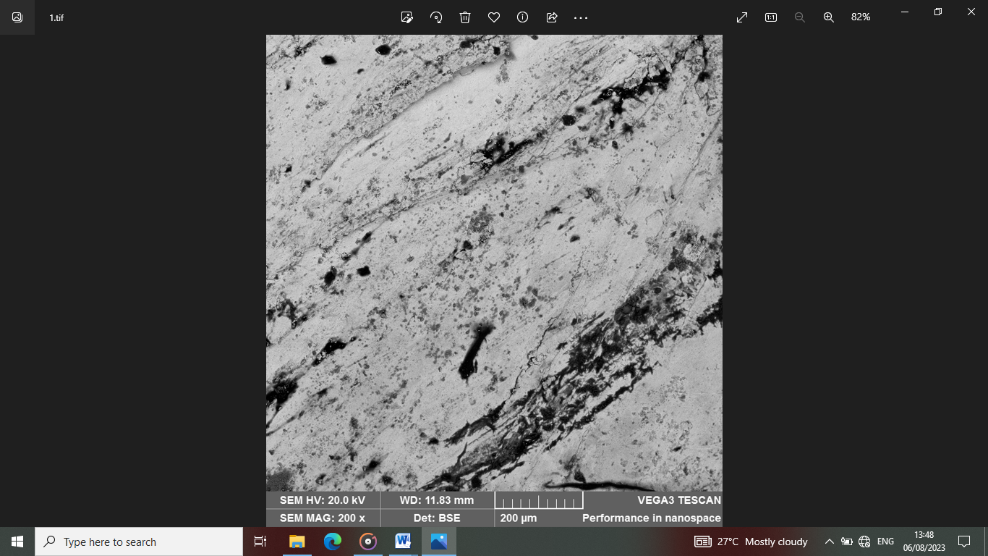
B
A
z
D
C
Figure 2, Scanning Electron Microscope (SEM) Results of Samples A, B, C and D.
Figure 3 shows the XRD pattern of samples A, B, C and D at room temperature. The peaks obtained are similar to those of 84.3Cu-11.9Al-3.8Ni wt.% for sample A, 84.78Cu-11.25Al-3.8Ni-0.15C wt.% for sample B, 84.05Cu-11.32Al-3.79Ni-0.3C wt.% for sample C and 83.92Cu-11.85Al-3.78Ni-0.45 wt.% for sample D.

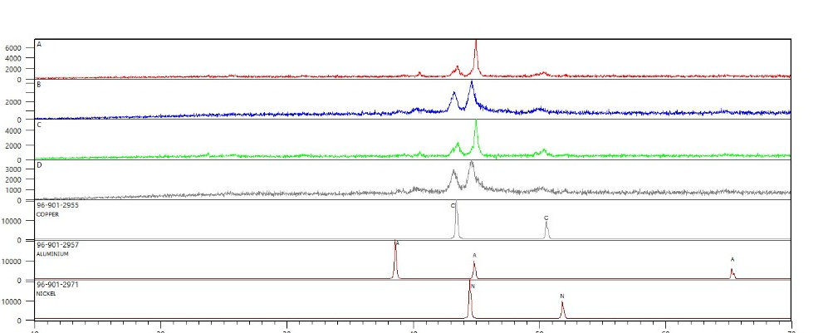
Figure 3, X-Ray Diffraction (XRD) Pattern of samples A, B, C and D

Table 1. Data obtained from the Avery Denison Fatigue Testing Machine.
SAMPLE  NAME | MOMENT (Kgfcm) | GUAGE LENGTH  (m) | FINAL LENGTH (m) | INITIAL REVOLUTION | FINAL REVOLUTION | DIAMETER (mm) | STRESS  (MPA) | NO OF CYCLES  (THOUDAND)
A | 65 | 45.35 | 52.52 | 5052 | 5053.7 | 5.4 | 412.31 | 1.7
 | 130 | 45.35 | 52.52 | 5054 | 5055.2 | 5.4 | 824.62 | 1.2
 | 195 | 45.35 | 52.52 | 5056 | 5056.7 | 5.4 | 1236.94 | 0.7
 | 260 | 45.35 | 52.52 | 5057 | 5057.5 | 5.4 | 1649.25 | 0.5
SAMPLE B | 65 | 45.35 | 52.52 | 5058 | 5059.5 | 5.4 | 412.31 | 1.5
 | 130 | 45.35 | 52.52 | 5060 | 5061.1 | 5.4 | 824.62 | 1.1
 | 195 | 45.35 | 52.52 | 5061.1 | 5061.7 | 5.4 | 1236.94 | 0.6
 | 260 | 45.35 | 52.52 | 5061.7 | 5062 | 5.4 | 1649.25 | 0.3
SAMPLE C | 65 | 45.35 | 52.52 | 5062 | 5063.8 | 5.4 | 412.31 | 1.8
 | 130 | 45.35 | 52.52 | 5064 | 5065 | 5.4 | 824.62 | 1.0
 | 195 | 45.35 | 52.52 | 5065 | 5065.7 | 5.4 | 1236.94 | 0.7
 | 260 | 45.35 | 52.52 | 5066 | 5066.5 | 5.4 | 1649.25 | 0.5
SAMPLE D | 65 | 45.35 | 52.52 | 5067 | 5067.9 | 5.4 | 412.31 | 0.9
 | 130 | 45.35 | 52.52 | 5068 | 5068.7 | 5.4 | 824.62 | 0.7
 | 195 | 45.35 | 52.52 | 5069 | 5069.4 | 5.4 | 1236.94 | 0.4
 | 260 | 45.35 | 52.52 | 5069.4 | 5069.2 | 5.4 | 1649.25 | 0.2

The fatigue life is a measure of the stress to number of cycles a material can sustain before failure of a specified nature occurs. It is obtained from the S-N Curve (Figure 4). It is a graphical display of stress (S) against the number of cycles (N) before failure by fatigue occurs.

Figure 4, S-N Curve for specimen A, B, C, D and the combined graphs
From the graphs in Figure 47-50 showing the S-N curves obtained, the fatigue type is a low cycle fatigue, as the fatigue failure occurs at high stress and low cycles, less than 10⁴ (George, 1988). Additional observation made was that as the value of applied stress reduces, the resulting number of stress cycles yielding fatigue failure reduces. The graph combined (Figure 51) helps to compare the fatigue life of specimen A, B, C and D. Specimen A and C at a particular value of stress on the combine graph, falls towards the right of specimen B and C, which indicates higher value of stress cycle or fatigue life. Increasing the stress value to 1649.25MPa, sample C containing 0.3% graphene display an optimum value of fatigue when in comparison with specimen/sample A, B and C. Sample D containing the highest amount of graphene of 0.45% gives the least fatigue life at a stress value of 149.25MPa, when compared with samples A, B and C. This is as a result of increased in graphene content above optimum amount.

4.0 Findings for the use of Computer Software for the Fatigue of SMA

4.1 D-Optimal Model Formulations
Based on D-Optimal design which is a sub-division of combined methodology of the Design Expert Software version 13.0, the model obtained for the accurate prediction of the fatigue life in terms of the coded factors is shown in Table 2.
Table 2, Experimental runs (input) and responses (output)
Output

Graphene (%)  Input | Cu  (%) | Al | Ni | Fatigue Life  cycles to failure (x10³)
0 | 84.3 | 11.9 | 3.8 | 1.7
0 | 84.78 | 11.25 | 3.8 | 1.2
0 | 84.05 | 11.32 | 3.79 | 0.7
0 | 83.92 | 11.85 | 3.78 | 0.5
0.15 | 84.3 | 11.9 | 3.8 | 1.5
0.15 | 84.78 | 11.25 | 3.8 | 1.1
0.15 | 84.05 | 11.32 | 3.79 | 0.6
0.15 | 83.92 | 11.85 | 3.78 | 0.3
0.3 | 84.3 | 11.9 | 3.8 | 1.8
0.3 | 84.78 | 11.25 | 3.8 | 1.0
0.3 | 84.05 | 11.32 | 3.79 | 0.7
0.3 | 83.92 | 11.85 | 3.78 | 0.5
0.45 | 84.3 | 11.9 | 3.8 | 0.9
0.45 | 84.78 | 11.25 | 3.8 | 0.7
0.45 | 84.05 | 11.32 | 3.79 | 0.4
0.45 | 83.92 | 11.85 | 3.78 | 0.2

A total of sixteen runs were carried out as part of the experiment (See Table 11). The linear model (see equation. 2) for forecasting fatigue life in terms of coded factors was created using the Design Expert Software version 13.0.
Table 3.

Table 3, Fatigue life in terms of coded factors

Source | Sum of Squares | Df | Mean square | F-value | P-value
Model | 3.22 | 9 | 0.3580 | 6.41 | 0.0174
⁽¹⁾Linear Mixture | 2.38 | 3 | 0.7933 | 14.20
AE | 0.0277 | 1 | 0.0277 | 0.4961
BE | 0.0349 | 1 | 0.0349 | 0.6249
CE | 0.0243 | 1 | 0.0243 | 0.4343
DE | 0.0295 | 1 | 0.0295 | 0.5277
AE² | 0.0009 | 1 | 0.0009 | 0.0165
BE² | 0.0000 | 0
CE² | 0.0429 | 1 | 0.0429 | 0.7685
DE² | 0.0000 | 0
Residual | 0.3353 | 6 | 0.0559
Lack of Fit | 0.3086 | 4 | 0.0772 | 5.79
Pure Error | 0.0267 | 2 | 0.0133
Cor Total | 3.56 | 15

88
Where FL is Fatigue Life. A, B, C, D represents the composition (%) of Graphene (C), Cu, Al, Nickel, respectively and E is Stress.

FL = -1.04A+2.35B-2.30C-28.87D-1.17AE-8.37BE-3.51CE+381.67DE-0.2827AE2 + 0.0000BE+ 8.04CE2 +0.0000DE2………………………….….(2)
The significance of each coefficient was obtained from the probability (p) values and residual least square error. According to table 12, the linear models were adequate in fitting the experimental result. The model F-Value of 14.85 was obtained with a chance of 0.02% occurrence due to noise. This indicates that the model is significant at 99% confidence interval. The stress and moment are significant model terms, thus they have significant effect on the fatigue life.

5.0 Analysis of Fatigue life using ANOVA (Analysis of Variance)

As indicated in Table 8 for the analysis, as inputs for the experiment, two parameters were chosen: the percentages of Cu and Graphene (C). The output parameter in this case was the number of cycles to failure, which determines the fatigue life.
From the Analysis of Variance result shown in Table 13, and by considering graphene and copper being dominant elements. The importance/significance of each coefficient is obtained from the residual least square error values and probability (p). It was observed that the linear model fits the results of the experiment at probability value of p < 0.05 adequately according to Table 4.

Table 4, ANOVA (Analysis of Variance) for Fatigue Life

Source DF Seq SS Contribution Adj SS Adj MS F-Value P-Value
Graphene (%) 3 0.5725 16.09% 0.5725 0.19083 9.41 0.004
Cu (%) 3 2.8025 78.78% 2.8025 0.93417 46.07 0.000
Error 9 0.1825 5.13% 0.1825 0.02028
Total 15 3.5575 100.00%

Table 4 is the ANOVA results and it signifies that Cu (%) with p-value far less than 0.05 is the most important factor affecting the fatigue life.

Table 5, Summary of the model

S R-sq R-sq(adj) PRESS R-sq(pred)
0.142400 0.9487 0.9145 0.576790. 83.79%

According to the model summary in Table 5 above, the fatigue life mathematical model indicates a satisfactory fit. The model's ability to forecast fatigue life is demonstrated by its R-squared result of 0.9487 and adjusted R-squared result of 0.9145.
Similarly, a 3D response surface plot is used to study the mutual interaction between input and output parameters (see Figure 5-7). These plots were generated using the Design Expert Software version 13.0. They show the relationships that exist among different parameters at a time in three dimensions.

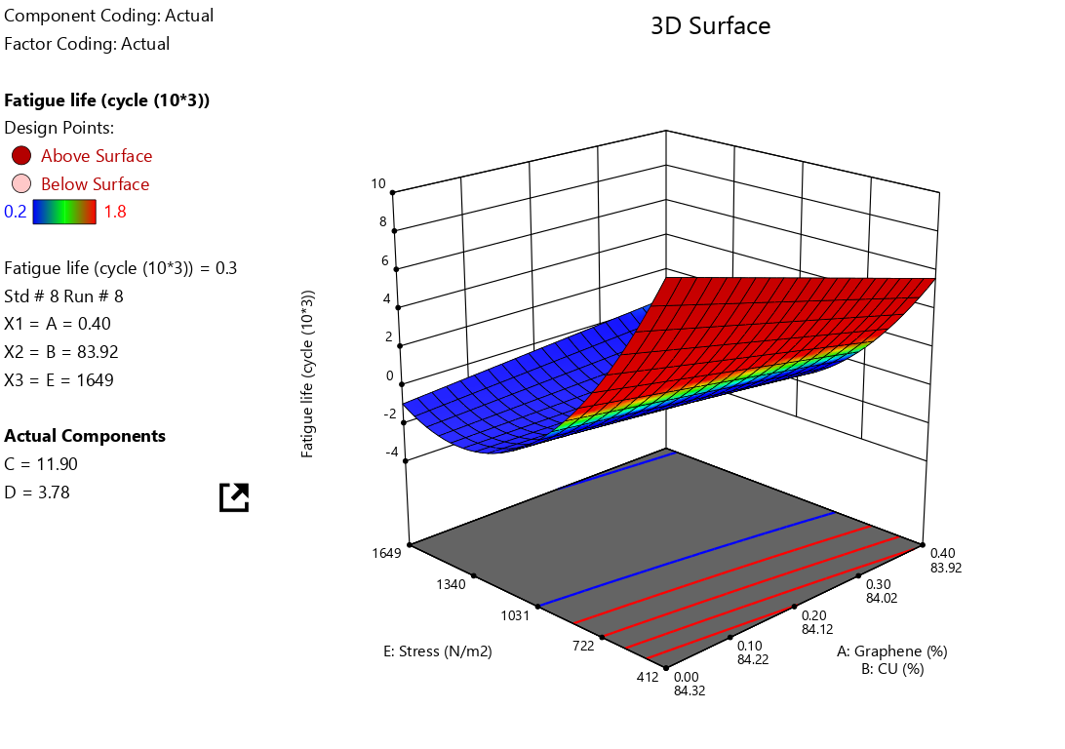
Figure 5, For fatigue life, a three-dimensional response surface plot A

Figure 5 shows that by increasing percentage of graphene with a decrease in the percentage of copper, fatigue life increases with a decrease in stress value.
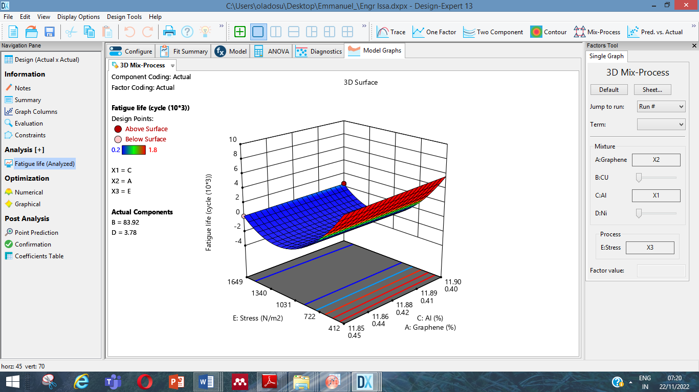
Figure 6, For fatigue life, a three-dimensional response surface plot B

Figure 6 shows that by decreasing the percentage of graphene with an increment in the percentage of Aluminium, fatigue life increases with a decrease in stress value.

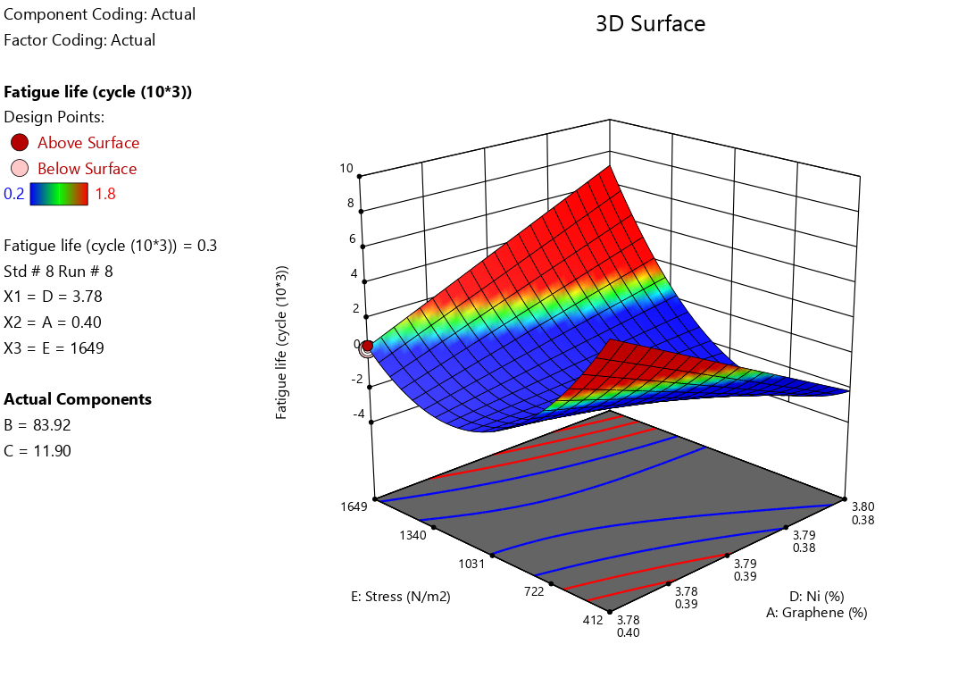
Figure 7, For fatigue life, a three-dimensional response surface plot C
Figure 7 shows that by decreasing percentage of graphene with an increase in the percentage of Nickel, fatigue life increases with a decrease in stress value.
Lastly, from the 3 D plots showing the mutual interaction of number of cycles and percentage content of copper (Cu), aluminium (Al), and graphene (C), Ni (nickel) and stress value, it is also observed that a higher fatigue life is attained at lower stress value. Thus increasing the applied stress on a component result to a reduction in its fatigue life.

6.0 Conclusion
This experimental research involving Shape Memory Alloy helps to investigate the relevance of quaternary to CuAlNi SMA hardness and fatigue properties. The weight of each sample was determined separately with a mettler weighing balance of 0.02 g precision for accuracy. Errors due to parallax were avoided in taking reading on weighing balance for casting and Rockwell scales for hardness test. Trace amount of graphene (0.15%, 0.3%, 0.45%) were added to Copper, Aluminium and Nickel through the method of mixture to produce CuAlNiC SMA and CuAlNi (control sample) through the method of casting.
A close study of the microstructure of the alloy produced utilizing EDS (Energy Dispersive X-ray Spectroscopy) and SEM (Scanning Electron Microscope) show that Secondary black compounds seen in all graphene-reinforced alloys are associated with higher quantities of carbon, which are found in the alloy with 0.45% graphene. This poses more dislocation impediment due to increased resistance to dislocation movement which is responsible for the increase hardness values and mechanical properties of SMA reinforced with graphene (CuAlNiC) as compared with the control sample without graphene (CuAlNi). Similarly, CuAlNiC containing 0.3% graphene display optimum fatigue properties during the test carried out on fatigue. This possibly is explained by the alloy's rather uniform structures from the micrograph. The likelihood of local deformations that can result in fatigue failure at fewer cycles is decreased by evenly distributed carbon. CuAlNiC containing 0.45% graphene display least fatigue properties and this could be that because of the spherical grains, there are discontinuities in the structure.
To investigate the relationship between fatigue life, stress, and the percentage composition of Cu, Al, Ni, and graphene (C), Design Expert Software version 13.0 was used. One advantage is that the modelling equation is easily accessible; making it simple to see how each input parameter affects the result. As a result, a new mathematical model for fatigue life is created. This model's R² of 0.9058 suggests a good fit. Therefore, this model can be used to calculate the fatigue life in SMA studies that include a quaternary element, such as graphene.

REFERENCES
[1] Callister, W. D. & Rethwisch, D. G.: Materıals Science and Engineering An Introduction. John Wiley & Sons, 10th ed. Inc. 209-250.
[2] Ataalla, T, Leary, M & Subic: A. Functional Fatigue of Shape Memory Alloys.
Hartl, D. J. & Lagoudas, D. C. Aerospace applications of shape memory alloys.
J. Aerospce Engrg. 221, 535-552.
[3] Petrini, L., & Migliavacca: F. Biomedical applications of shape memory alloys. J. Metall 1–14 https://doi.org/10.1155/2011/501483.
[4] Ma, J., Karaman, I., & Noebe, R. D.: High temperature shape memory alloys. Int Mater Rev 55, 257–315 https://doi.org/10.1179/095066010X12646898728363.
[5] Tsuchiya, K.: Mechanisms and properties of shape memory effect and superelasticity in alloys and other materials: A practical guide, In: Shape Memory and Superelastic Alloys, Woodhead Publishing, 3–14. https://doi.org/10.1533/9780857092625.1.3.
[6] Kumar, P.K. & Lagoudas, D.C.: Introduction to Shape Memory Alloys. Shape Memory Alloys Modeling and Engineering Applications. Springer Science.

[7] Saud, S. N., Hamzah, E., Abubakar, T. A., & Hosseinian, R.: A Review on Influence of Alloying Elements on the Microstructure and Mechanical Properties of Cu-Al-Ni Shape Memory Alloys. Jurnal Teknologi 64, 1. https://journals.utm.my/jurnalteknologi/article/view/1338/1525.

[8] Safaa Najah, S. A.: Cu-Based Shape Memory Alloys: Modified Structures and Their Related Properties. DOI: https://doi.org/10.5772/intechopen.86193.
[9] Al-Humairi, S. N. S.: Cu-based shape memory alloys: modified structures and their related properties. Recent Advancements in the Metallurgical Engineering and Electrodeposition, 25. http://dx.doi.org/10.5772/intechopen.86193.
[10] Jani, J. M., Leary, M., Subic, A., & Gibson, M. A.: A review of shape memory alloy research, applications and opportunities. Mater Des 56, 1078-1113. https://doi.org/10.1016/j.matdes.2013.11.084.
[11] Prasad, K., Bazaka, O., Chua, M., Rochford, M., Fedrick, L., Spoor, J., Symes, R., Tieppo, M., Collins, C., Cao, A., Markwell, D., Ostrikov, K., Bazaka, K.: Metallic biomaterials: Current challenges and opportunities. Materials. 10 (8),884. https://doi.org/10.3390/ma10080884.
[12] Canbay, C. A., Karaduman, O., & Özkul, İ.: Lagging temperature problem in DTA/DSC measurement on investigation of NiTi SMA. Mater Sci: Materials in Electronics, 31(16), 13284-13291. https://doi.org/10.1007/s10854-020-03881-y.
[13] Lojen, G., Anžel, I., Kneissl, A., Križman, A., Unterweger, E., Kosec, B., & Bizjak, M. Microstructure of rapidly solidified Cu–Al–Ni shape memory alloy ribbons. Journal of Materials Processing Technology. 162-163: 220-229. https://doi.org/10.1016/j.jmatprotec.2005.02.196.
[14] López-Ferreño, I., Gómez-Cortés, J. F., Breczewski, T., Ruiz-Larrea, I., Nó, M. L., & San Juan, J. M.: High-temperature shape memory alloys based on the Cu-Al-Ni system: design and thermomechanical characterization. Journal of Materials Research and Technology, 9(5), 9972- 9984. https://doi.org/10.1016/j.jmrt.2020.07.00.
[15] Dasgupta, R.: A look into Cu-based shape memory alloys: Present scenario and future prospects. Mater Research, 29(16), 1681-1698. https://doi.org/10.1557/jmr.2014.189.
[16] W. A. Issa, H. Camur, M. Savas: A study of the effect of graphene on the fatigue life of CuAlNi Shape Memory Alloy. Technical gazette. Vol. 31 (5); 1653-1659. https://doi.org/10.17559/TV-20240212001324
[17] Issa, W. A., Camur, H., & Savas, M.: A brief review of characteristics and applications of shape memory alloys in engineering and related fields. IJMET, 12(9), 34-43. https://doi.org/10.34218/IJMET.12.9.2021.004.
[18] Karaduman, O., & Canbay, C.: A. Investigation of CuAlNi Shape Memory Alloy Doped with Graphene. Mater & Electronic Dev 3, 8-14.
[19] Sellitto, A., & Riccio, A.: Overview and future advanced engineering Applications for morphing surfaces by shape memory alloy materials. Maters 12, 708. https://doi.org/10.3390/ma12050708.
[20] Leal, P. B., & Savi, M. A. Shape memory alloy-based mechanism for aeronautical application: Theory, optimization and experiment. Aerospace Sci & Tech. 76, 155-163, https://doi.org/10.1016/j.ast.2018.02.010.
[21] Oliveira, J. P., Crispim, B., Zeng, Z., Omori, T., Braz Fernandes, F. M., Miranda, R. M.: Microstructure and mechanical properties of gas tungsten arc welded Cu-Al-Mn shape memory alloy rods. Mater Proc. Tech. 217, 93-100. https://doi.org/10.1016/j.jmatprotec.2019.03.020.
[22] Yang, S., Zhang, J., Chen, X., Chi, M., Wang, C., Liu, X.: Excellent superelasticity and fatigue resistance of Cu-Al-Mn-W shape memory single crystal obtained only through annealing polycrystalline cast alloy. Mater Sci. & Engrg. 749, 249-254. https://doi.org/10.1016/j.msea.2019.02.033 .
[23] Tian, J., Zhu, W., Wei, Q, Wen, S., Li, S., Song, B., Shi, Y.: Process optimization, microstructures and mechanical properties of a Cubased shape memory alloy fabricated by selective laser melting. Alloys and Compounds. 785, 754-764. https://doi.org/10.1016/j.jallcom.2019.01.153.
[24] Vajpai, S. K., Dube, R. K., & Sangal, S.: Microstructure and properties of Cu-Al-Ni shape memory alloy strips prepared via hot densification rolling of argon atomized powder preforms. Mater. Sci. & Engrg. 529 (1), 378-387.
[25] Razooqi, R. N., Razej, K. H., Abdulhameed, A. T., & Irhayyim, S. S.: The physical and mechanical properties of a shape memory alloy reinforced with carbon nanotubes (CNTs). Tikrit Journal of Pure Science, 23 (9), 80-88. http://tjps.tu.edu.iq/index.php/j/article/view/596.
[26] Saud, S. N., Hamzah, E., Abu Bakar, T. A., & Abdolahi, A.: Influence of addition of carbon nanotubes on structure–properties of Cu–Al–Ni shape memory alloys. Mater Sci & Tech., 30 (4), 458-464. https://doi.org/10.1179/1743284713Y.0000000379.
[27] Vanderson, M. D., Sergio, A. O., Marcelo, A. S., Pedro Manuel, C. P., & Luis Felipe, G.: Fatigue on shape memory alloys: Experimental observations and constitutive modeling. Inter Journal of Solids and Struct. 213, 1-24. https://doi.org/10.1016/j.ijsolstr.2020.11.023.
[26] Bhandari, V. D.: Design of machine elements. MC GRAW HILL INDIA (3 ed.). 149-153.
[28] Ugural, A. C., & Fenster, S. K.: Advanced Mechanics of Materials and Applied Elasticity. Pearson Education, Inc. (5 ed.). 188-190.
[29] Obiukwu, O., Nwafor, M., & Grema, L.: The effect of surface finish on the low cycle fatigue of low and medium carbon steel. International Conference on Mechanical and Industrial Engineering (ICMIE 15) Harare, Zimbabwe July 14-15.

